1. What is jQuery ?

ANS :

jQuery takes a lot of common tasks that require many line of javascript code to accomplish, and wraps them into methods that you can call with a single line of code.

jQuery also simplifies a lot of the complicated things from javascript, like AJAX call and DOM manipulation.

2. How to apply CSS using jQuery, How to add class and remove class in jquery, jquery Animation ?

ANS :

Apply CSS using jQuery

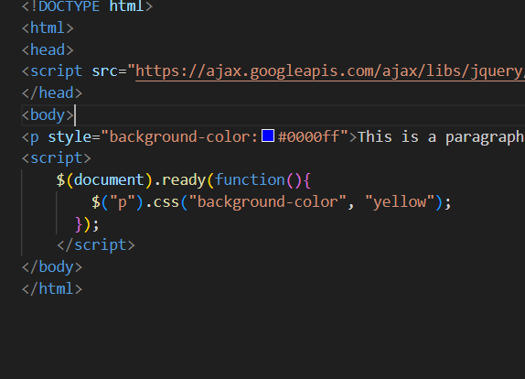

add class and remove class in jquery

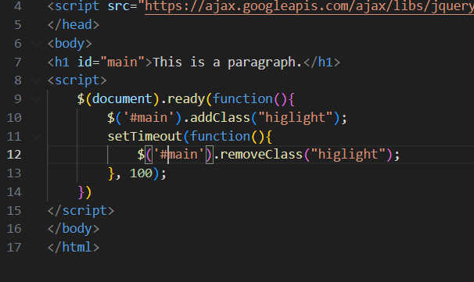

jquery Animation

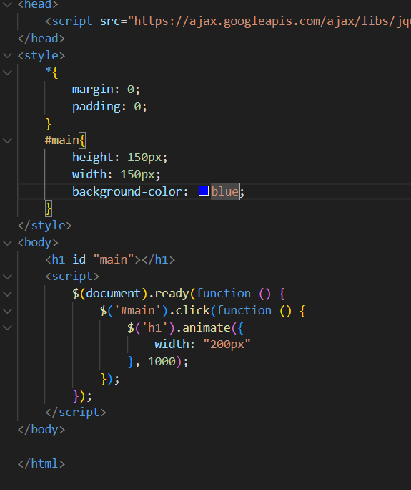

3.How to create slider with animatin ?

ANS :

